NUCL 402 Report Outline

Fast Reactor Core Design with a Focus on DOE work at and with Argonne National Laboratories

# Section II: Tech Specs (Alex)

## Fuels, Design, and Moderator

Fast Reactor core design is often presented in a way that highlights its key differences from Light Water Reactor design. This has proven to be a useful and rigorous way to provide understanding because of the comfort many nuclear engineers have with Light water reactors. It is with this approach that a quick discussion of the fuels used, the design of the core, and the moderator materials will be presented here.

Fuel design is the key constituent to Fast Reactor Design, and also the key difference between Fast Reactors and LWRs. Because of the difference in emphasis on the energy range of the neutrons, the fuel must be different than that of Light Water Reactors. The flux spectra of a Fast Reactor and an LWR are shown below.

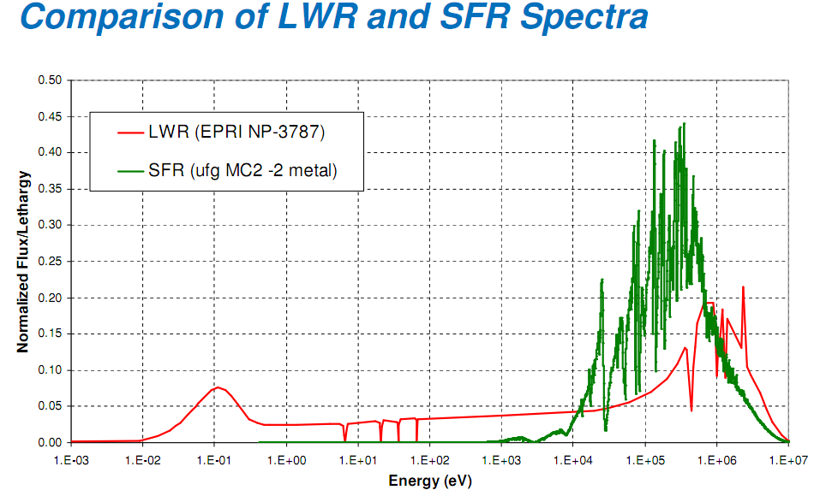

Figure Comparison of LWR and SFR Spectra [1]

This spectra shows that the neutron spectra within a Fast Reactor are never thermal. Because of the absence of thermal neutrons within the core, the use of U-235 in the fuel would be inappropriate and wasteful. Thus, different fuels must be used. The most common Fast Reactor fuel is Pu-239 or U-238. These both provide fast fissions, although Pu-238 has been shown to provide better fission to absorption ratios than U-238. The differences will be discussed during the Optimization Considerations section. Other possible fuels for fast reactors are Thorium, Neptunium, and other isotopes of Plutonium and Uranium. In Fast Reactor tests such as ZPR and ZPPR, these fuels are machined into plates and used in drawers within the core.

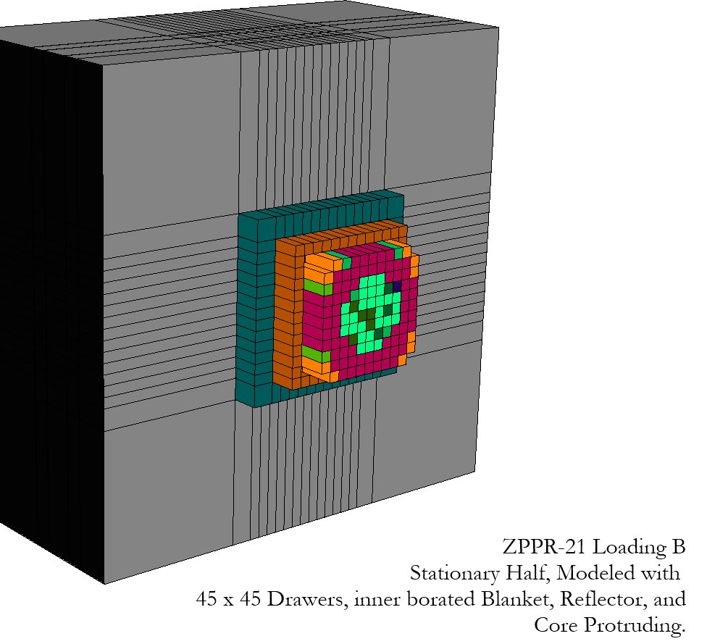 The amount of fast neutrons within the core necessitates a much different core design than that of a fast reactor. Moderation is not a key concern within fast reactors, and in fact should be minimized. Leakage, because of the speed and penetrating power of fast neutrons (compared to thermal neutrons in an LWR), is much higher and is the key concern for minimization by geometric design of the fast reactor design. Reactors such as ZPR and ZPPR are designed in a cylindrical type design, with an approximate circle of fuel designed in the center of the drawers. This was surrounded with a borated blanket, reducing leakage of neutrons to the outside. The borated blanket was then surrounded by a depleted Uranium reflector, which is used to scatter leaked neutrons back into the core without moderating them. Finally, this is surrounded by many layers of gap as structural support [2] [3]. A rendering of this setup can be seen in the figure at right [4].

Figure ZPPR-21 Loading B [4]

As was discussed in the geometric design of fast reactors, moderation is minimized in Fast Reactors as a way to increase the amount of neutrons able to be fissioned. This can be difficult, especially when choosing a coolant material. In general, inelastic scattering will provide moderation, so any low atomic weight materials will moderate neutrons. This limits the realm of all structural materials to high atomic weight materials. Because of this constraint, water may not be used as a coolant, and instead sodium is often used. With the use of sodium as a coolant, the slowing down power of the core can be decreased to 1% of that from an LWR, but design challenges are brought about when dealing with molten aluminum, particularly in refueling and startup situations [1].

## Optimization Considerations

Optimization of fast reactors has three different specific thrusts. One is the attempt to moderate neutrons as little as possible, which requires use of alternative coolants and building materials. Another is the attempt to remove resonance absorptions within non-fissile elements. The final is the attempt to reflect as many fast neutrons as possible into fuel regions, which can be difficult to do without moderating those neutrons.

As stated in the core design section, alternative coolants are often used to drop the moderation of the reactor down to about 1% of the power of a typical LWR. These coolants have been well tested, and although sodium has the highest moderation of any material in a Fast Reactor, it is currently the coolant of choice for these systems. But moderation does not only happen within the coolant and building materials, but within the fuel itself.

Fast reactor fuels can come in metal, oxide, nitride, and carbide forms. Metal uranium is hard to deal with because of its low melting temperature and also its thermal expansion and heat capacity, but has small moderation within the fuel itself. The combination with lower atomic weight elements (oxygen, nitrogen, and carbon) create fuel material that has much more useful thermal properties, but do moderate neutrons within the fuel themselves. Although oxide type Plutonium fuels can have melting points up to 3000 K, the moderation increase is noticeable within the fast spectra of the reactor [1].

Reflection of neutrons is a difficult problem to solve within a power reactor. Zero Power Reactors such as ZPR and ZPPR use a borated shield to cut down the neutron flux outside the core region and then depleted uranium to scatter fast neutrons back into the core region. Power type fast reactors such as the SuperPRISM and the Burner design use “blankets” but do not use as high of a boron concentration in this shield to “harvest” more neutrons. In general, the optimization of geometry within these reactors includes the use of an inner blanket, a radial blanket, an axial blanket, and a reflector.

Optimization has general been done using experimental procedures, especially in the 1970s. For instance, ZPPR-21 is a five step test done by Argonne Laboratory to quantify the differences between U-238 fuel and Pu-239. Each of the five loadings (A-E) had differing amounts of U and Pu in the core, going from all U to all Pu. Foil irradiation as well as fission chamber analysis was done on the power of the reactor and the flux distribution within the reactor. This provided good conclusions for use in design of the different fuels within the reactors [4].

Experimental optimization is extremely expensive, and with increasing computing power, has been less preferred when compared to neutronics type analysis. Argonne, which has a focus on Fast Reactors within their Nuclear Engineering department, is currently doing computational work on Fast Reactor neutronics. The NEAMES program is a computationally based integral reactor simulation. The neutronics side of this code, the PROTEUS methodology, is currently replicating all ZPR and ZPPR tests to verify computational results with experimental results. Because of the computational power at Argonne, the PROTEUS methodology is able to solve the transport equation in three dimensions using large and complex reactor geometries, never before done with Fast Reactors. Once fully benchmarked, this code, or others like it, could be used for more advanced fast reactor design and optimization [3] [5].

## Flux and Power Distributions

The flux distribution in a Fast Reactor should be exactly opposite (in terms of energy groups) that of an LWR. The fast flux in a Fast Reactor should be high in fuel regions, and (contrary to LWR flux profiles) the thermal flux should be as low as possible everywhere.

With this in mind, flux calculations must be made with different assumptions and regions than in LWRs. The splitting of groups within fast reactors does not depend on the assumption of no upscattering in thermal regions because there should be very little flux in thermal regions. This allows for the use of only 33 energy groups. Self-shielding is ignored when only using 33 groups, but ultrafine groups (more than 2000) would be needed to correctly model self-shielding within a fast reactor. Because of the increased number of energy groups for bulk reactor analysis (LWR analysis often only has several groups in bulk reactor analysis), spatial regions are often homogenized to use less computing power.

Because of the difficulty and fineness of energy groups, the most useful distribution to be considered in a Fast Reactor is that of power distribution. The power distribution will have two components, the radial distribution (as most Fast Reactors are cylindrical) and the axial distribution. The radial distribution will have its maximum at the center and (at criticality) will decrease by a cosine function until it reaches the blanket region. There it will drop quickly, and will then increase slightly but quickly when entering the reflector region.

A typical radial flux distribution is shown below, which shows the decrease into the blanket, and the increase at the reflector again. This model was created without using any control rods, and thus gives a pure curve for the power throughout the regions. 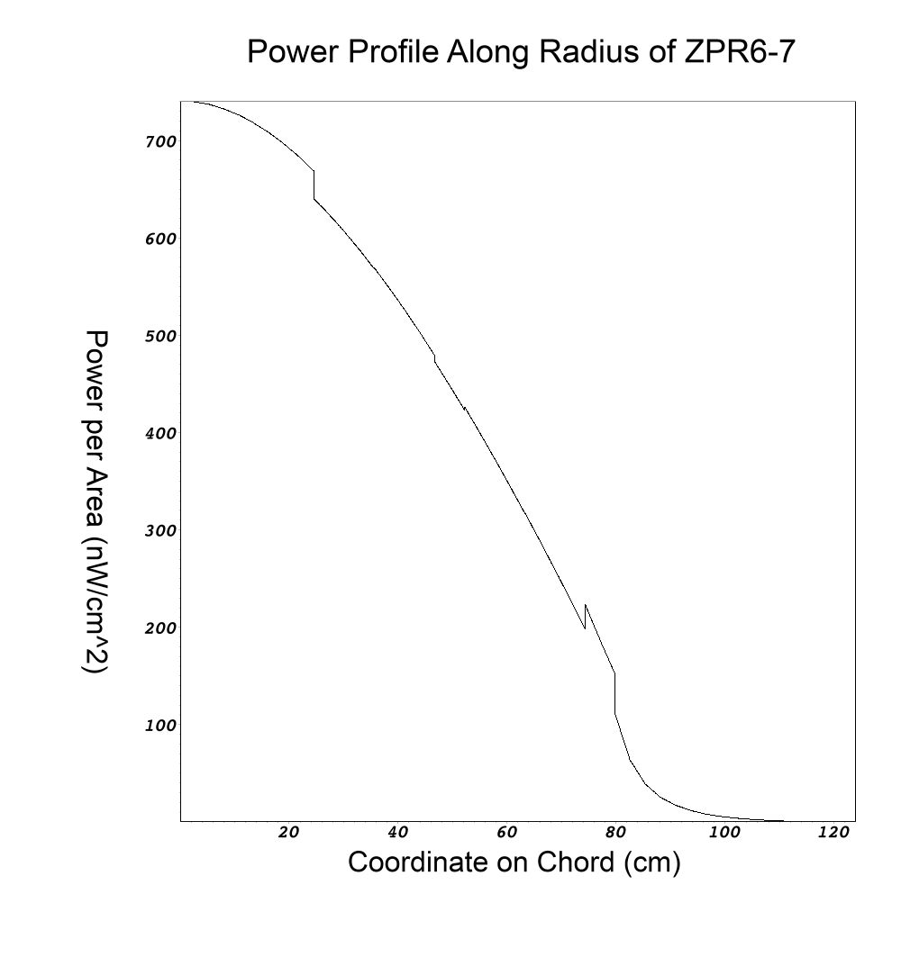

Figure Power Profile Along Radius of ZPR6-7 [6]

This will come in contrast to the power reactor power distribution shown below. Several notes to be considered when considering the power reactor distribution below is the inclusion of control rods (which explain the large dips in power level through the radial distribution), and the fact that the distribution was only taken through the core region. This shows in better detail how the power within the core will realistically be distributed, but does not show the interest of the blanket drop off and the power increase within the blanket.

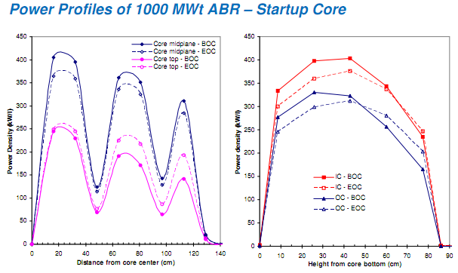

Figure Power Distribution of 1000 MWth ABR [1]

# Works Cited (Alex)

x

|  |  |
| --- | --- |
| [1] | Robert N. Hill, "Fast Reactor Physics and Core Design," in *NRC Topical Seminar on Sodium Fast Reactors*, Two White Flint, Rockville, MD, 2007. |
| [2] | Richard M Lell, James A Morman, Robert W Schaefer, and Richard D McKnight, "ZPR-6 Assembly 7 Experiments: A Fast Reactor Core with Mixed (Pu,U)-Oxide Fuel and Sodium with a Thick Depleted Uranium Reflector," Argonne, IL, 2008. |
| [3] | L. G. LeSage, "An Overview of the Argonne National Laboratory Fast Critical Experiments 1963-1990," Argonne, IL, 2001. |
| [4] | Richard D McKnight, Richard M Lell, Robert W Schaefer, and Amr Mohamed, "ZPPR-21 Phases B Through E: Cylindrical Assemblies of Mixed Fissile Pu and U Metal Reflected By Graphite," Argonne, IL, 2001. |
| [5] | Idaho National Laboratory. (2010) Idaho National Laboratory. [Online]. <http://www.inl.gov/research/> |
| [6] | Alex Hagen, "Setting Up Validation Benchmarks for Deterministic Neutron Transport Methodologies on Fast Reactors," Argonne National Laboratory, Chicago, IL, SULI Program Thesis 2011. |
| [7] | Argonne National Laboratory. (1968, February) Photograph of ZPR Facility. Photograph. [Online]. [Argonne Intranet](Argonne%20Intranet) |
| [8] | Charles Forsberg, "Safety and Licensing Aspects of the Molten Salt Reactor," in *American Nuclear Society Annual Meeting*, Pittsburg, PA, 2004. |

x

# Appendices (Alex)

[7]